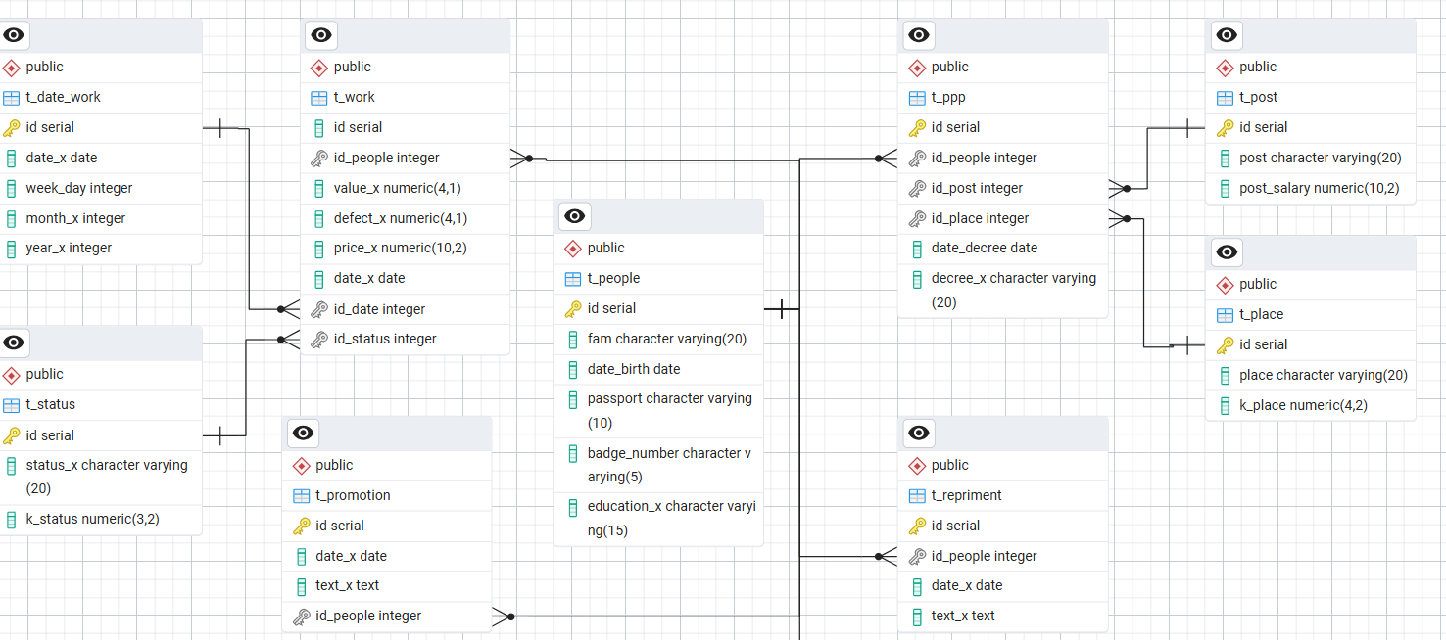

1. Выполнить проектирование хранимой процедуру (ХП), обеспечивающих начисление заработной платы (ЗП) каждому работнику в указанный месяц заданного года.

**Формулы начисления ЗП**

$$ЗП_{смена}=\frac{оклад*k_{status}*k_{place}}{количество смен в месяц}-$$

для начальников и тех рабочих, которые отсутствовали на рабочем месте по уважительной причине.

Для рабочих, которые трудились за станком

$$ЗП_{смена}=\frac{стоимость одного изделия(объем-брак)}{8}$$

Логика работы ХП должна предусматривать:

* организацию корректного выхода из процедуры, предусматривающую освобождение памяти от временной таблицы;
* после обработки всех рабочих смен выполнение в процедуре операции переноса данных в таблицу *t_salary*.

CREATE OR REPLACE PROCEDURE sp_calculate_salary (

p_month INT, -- Месяц (1-12)

p_year INT -- Год (например, 2025)

)

LANGUAGE plpgsql

AS $$

DECLARE

v_shift_count INT; -- Количество рабочих дней в месяце

BEGIN

-- 1. Подсчет рабочих дней в месяце

SELECT COUNT(*) INTO v_shift_count

FROM t_date_work

WHERE date_part('month', date_x) = p_month

AND date_part('year', date_x) = p_year;

-- 2. Создание временной таблицы для расчетов по всем цехам

DROP TABLE IF EXISTS t_temp_salary_detail;

CREATE TEMP TABLE t_temp_salary_detail AS

SELECT

p.id AS id_people,

p.fam,

p.passport,

po.post,

po.post_salary,

pl.k_place,

st.id AS status_id,

st.k_status,

w.value_x,

w.defect_x,

w.price_x,

d.date_x

FROM t_people p

JOIN t_ppp pp ON p.id = pp.id_people

JOIN t_post po ON pp.id_post = po.id

JOIN t_place pl ON pp.id_place = pl.id

JOIN t_work w ON p.id = w.id_people

JOIN t_status st ON w.id_status = st.id

JOIN t_date_work d ON w.id_date = d.id

WHERE

pp.date_decree = (

SELECT MAX(px.date_decree)

FROM t_ppp px

WHERE px.id_people = p.id AND px.date_decree <= d.date_x

)

AND date_part('month', d.date_x) = p_month

AND date_part('year', d.date_x) = p_year;

-- 3. Агрегация данных по сотрудникам

DROP TABLE IF EXISTS t_temp_salary;

CREATE TEMP TABLE t_temp_salary AS

SELECT

id_people,

fam,

passport,

-- Берем последний оклад

(SELECT post_salary FROM t_temp_salary_detail d

WHERE d.id_people = t.id_people

ORDER BY date_x DESC LIMIT 1) AS post_salary,

-- Берем последний коэффициент цеха

(SELECT k_place FROM t_temp_salary_detail d

WHERE d.id_people = t.id_people

ORDER BY date_x DESC LIMIT 1) AS k_place,

-- Суммируем дни по всем цехам

SUM(CASE WHEN status_id = 2 THEN 1 ELSE 0 END) AS day_bus_trip,

SUM(CASE WHEN status_id = 3 THEN 1 ELSE 0 END) AS day_disease,

SUM(CASE WHEN status_id = 4 THEN 1 ELSE 0 END) AS day_vacation,

COUNT(status_id) AS day_all,

-- Расчет зарплаты по компонентам

ROUND(SUM(

CASE

WHEN status_id = 2 THEN (post_salary * k_status * k_place) / v_shift_count

ELSE 0

END

), 2) AS salary_bt,

ROUND(SUM(

CASE

WHEN status_id = 3 THEN (post_salary * k_status * k_place) / v_shift_count

ELSE 0

END

), 2) AS salary_d,

ROUND(SUM(

CASE

WHEN status_id = 4 THEN (post_salary * k_status * k_place) / v_shift_count

ELSE 0

END

), 2) AS salary_v,

-- Общая зарплата

ROUND(SUM(

CASE

WHEN post = 'рабочий' AND status_id > 1 THEN

(post_salary * k_status * k_place) / v_shift_count

WHEN post = 'рабочий' AND status_id = 1 THEN

(value_x - defect_x) * price_x

WHEN post IN ('начальник','заместитель','бригадир') THEN

(post_salary * k_status * k_place) / v_shift_count

ELSE 0

END

), 2) AS salary_all

FROM t_temp_salary_detail t

GROUP BY id_people, fam, passport;

-- 4. Сохранение результатов в основную таблицу

IF NOT EXISTS (SELECT * FROM information_schema.tables WHERE table_name = 't_salary') THEN

CREATE TABLE t_salary (

fam character varying(20),

passport character varying(10),

month_x double precision,

year_x double precision,

day_bus_trip bigint,

day_disease bigint,

day_vacation bigint,

day_all bigint,

salary_bt numeric,

salary_d numeric,

salary_v numeric,

salary_all numeric

);

END IF;-- Удаляем старые данные за этот месяц

DELETE FROM t_salary

WHERE month_x = p_month AND year_x = p_year;

-- Вставляем новые данные

INSERT INTO t_salary (

fam, passport, month_x, year_x,

day_bus_trip, day_disease, day_vacation, day_all,

salary_bt, salary_d, salary_v, salary_all

)

SELECT

fam, passport, p_month::double precision, p_year::double precision,

day_bus_trip, day_disease, day_vacation, day_all,

salary_bt, salary_d, salary_v, salary_all

FROM t_temp_salary;

RAISE NOTICE 'Зарплата за %-% успешно рассчитана', p_month, p_year;

END;

$$;

--Рассчитываем ЗП с января по май 2025 года.

CALL sp_calculate_salary(1, 2025);

CALL sp_calculate_salary(2, 2025);

CALL sp_calculate_salary(3, 2025);

CALL sp_calculate_salary(4, 2025);

CALL sp_calculate_salary(5, 2025);

--Выводим данные. Группируем по месяцу.

SELECT *

FROM public.t_salary

order by month_x;

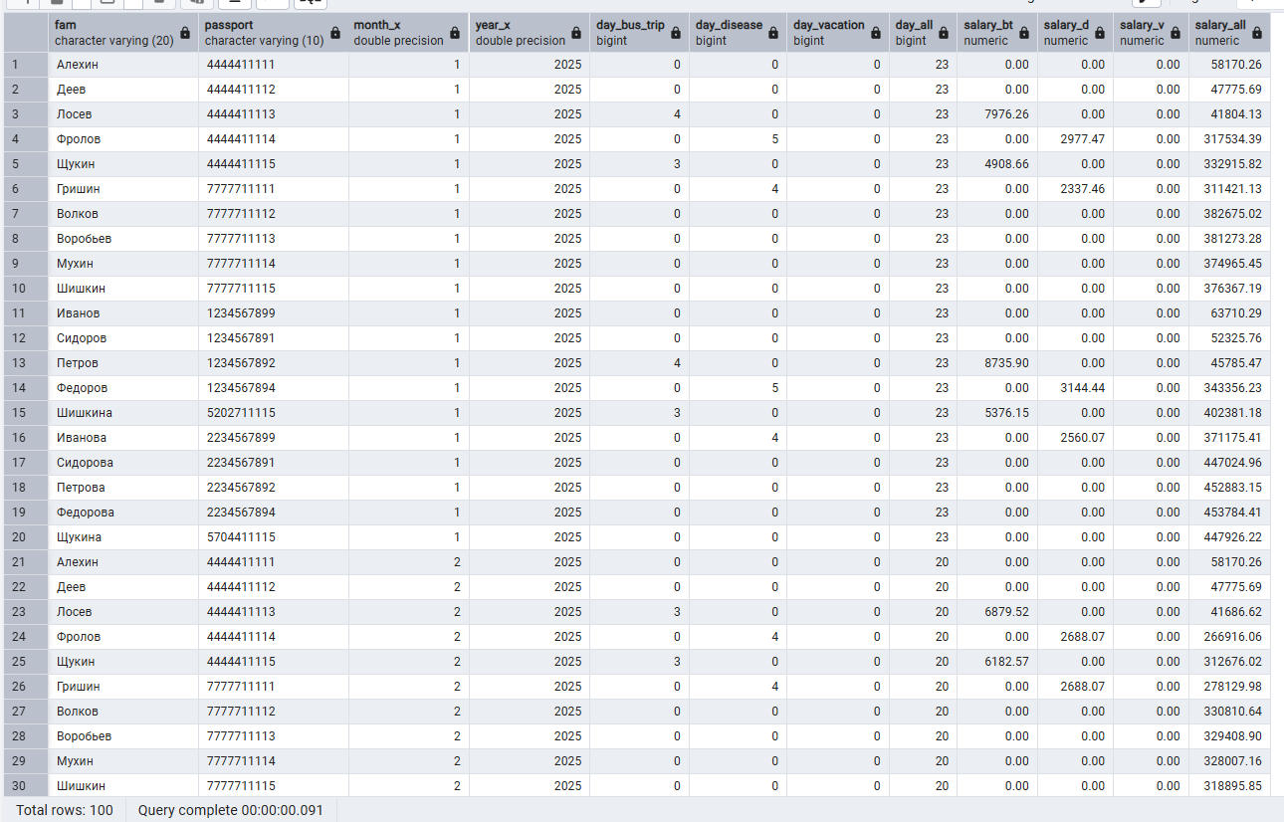

1. Выполнить проектирование ХП, обеспечивающей вывод результатов работников, которые отсутствовали на рабочем месте в виде:

CREATE OR REPLACE PROCEDURE sp_employee_absences_report(

m_x INT,

y_x INT

)

LANGUAGE 'plpgsql'

AS $BODY$

DECLARE

cnt_shift INT := 1;

BEGIN

-- Расчет количества рабочих дней в месяце

SELECT COUNT(date_x)

INTO cnt_shift

FROM t_date_work

WHERE date_part('month', date_x) = m_x AND

date_part('year', date_x) = y_x;

DROP TABLE IF EXISTS t_temp;

-- Создание временной таблицы с данными о работе

CREATE TEMP TABLE t_temp ON COMMIT DROP AS

SELECT

d.date_x,

w.id_people,

w.id_status,

px.id_post,

px.id_place,

w.value_x,

w.defect_x,

w.price_x,

ROUND(po.post_salary * pl.k_place * st.k_status / cnt_shift, 2) AS day_salary,

date_part('month', d.date_x) AS month_x,

date_part('year', d.date_x) AS year_x,

pl.place AS workshop

FROM

t_date_work AS d

JOIN t_work AS w ON d.id = w.id_date

JOIN t_status AS st ON st.id = w.id_status

JOIN t_ppp AS px ON w.id_people = px.id_people

JOIN t_post AS po ON px.id_post = po.id

JOIN t_place AS pl ON px.id_place = pl.id

WHERE

px.date_decree = (

SELECT MAX(q.date_decree)

FROM t_ppp AS q

WHERE px.id_people = q.id_people AND q.date_decree <= d.date_x

) AND

date_part('month', d.date_x) = m_x AND

date_part('year', d.date_x) = y_x;

-- Создание или обновление таблицы отчетности

IF NOT EXISTS (

SELECT *

FROM information_schema.tables

WHERE table_name = 't_employee_absences'

AND table_schema = 'public'

) THEN

-- Создание таблицы отчетности, если она не существует

CREATE TABLE t_employee_absences AS

SELECT

t.workshop,

t.month_x,

t.year_x AS year_x,

COUNT(CASE WHEN t.id_status = 2 THEN 1 END) AS days_business_trip,

COUNT(CASE WHEN t.id_status = 3 THEN 1 END) AS days_sick_leave,

COUNT(CASE WHEN t.id_status = 4 THEN 1 END) AS days_vacation,

COUNT(CASE WHEN t.id_status > 1 THEN 1 END) AS total_days_absence,

COALESCE(SUM(CASE WHEN t.id_status = 2 THEN t.day_salary END), 0) AS salary_business_trip,

COALESCE(SUM(CASE WHEN t.id_status = 3 THEN t.day_salary END), 0) AS salary_sick_leave,

COALESCE(SUM(CASE WHEN t.id_status = 4 THEN t.day_salary END), 0) AS salary_vacation,

COALESCE(SUM(CASE WHEN t.id_status > 1 THEN t.day_salary END), 0) AS total_salary_absences

FROM

t_temp t

GROUP BY

t.workshop, t.month_x, t.year_x;

ELSE

-- Проверка, существуют ли уже данные за указанный период

IF NOT EXISTS (

SELECT *

FROM t_employee_absences

WHERE month_x = m_x AND year_x = y_x

) THEN

-- Вставка новых данных

INSERT INTO t_employee_absences (

workshop,

month_x,

year_x,

days_business_trip,

days_sick_leave,

days_vacation,

total_days_absence,

salary_business_trip,

salary_sick_leave,

salary_vacation,

total_salary_absences

)

SELECT

t.workshop,

t.month_x,

t.year_x,

COUNT(CASE WHEN t.id_status = 2 THEN 1 END) AS days_business_trip,

COUNT(CASE WHEN t.id_status = 3 THEN 1 END) AS days_sick_leave,

COUNT(CASE WHEN t.id_status = 4 THEN 1 END) AS days_vacation,

COUNT(CASE WHEN t.id_status > 1 THEN 1 END) AS total_days_absence,

COALESCE(SUM(CASE WHEN t.id_status = 2 THEN t.day_salary END), 0) AS salary_business_trip,COALESCE(SUM(CASE WHEN t.id_status = 3 THEN t.day_salary END), 0) AS salary_sick_leave,

COALESCE(SUM(CASE WHEN t.id_status = 4 THEN t.day_salary END), 0) AS salary_vacation,

COALESCE(SUM(CASE WHEN t.id_status > 1 THEN t.day_salary END), 0) AS total_salary_absences

FROM

t_temp t

GROUP BY

t.workshop, t.month_x, t.year_x;

ELSE

RAISE NOTICE 'Данные за указанный период уже существуют!';

END IF;

END IF;

-- Вывод результатов

RAISE NOTICE 'Отчет по отсутствиям сотрудников за %/%:', m_x, y_x;

END;

$BODY$;

--Расчет и добавление данных

CALL sp_employee_absences_report(1, 2025);

CALL sp_employee_absences_report(2, 2025);

CALL sp_employee_absences_report(3, 2025);

CALL sp_employee_absences_report(4, 2025);

CALL sp_employee_absences_report(5, 2025);

--Просмотр данных

SELECT *

FROM public.t_employee_absences;

